**Vanier College**

**Faculty of Science and Technology**

**System Development 420-436-VA**

Deliverable 06

**Grey Team**

Gennaro Finelli

Mohammed Hosein Ali

Alexandre Pham

Wayne De Leon

In collaboration with CyberStation

**(Code from our eCommerce class will be used for certain features of this project)**

**We, the Grey Team, certify that this assignment is our own work**

I, Gennaro Finelli, student ID# 2268107, certify that I have contributed to this deliverable, G.F

I, Mohammed Hosein Ali, student ID# 2055295, certify that I have contributed to this deliverable, M.H.A

I, Alexandre Pham, student ID# 2048017, certify that I have contributed to this deliverable, A.P

I, Wayne De Leon, student ID# 2179710, certify that I have contributed to this deliverable, W.D

Table of Contents

Executive Overview 3

Revised Summary Narrative 4

Business Problem 5

Business Problem 5

List of usability guidelines 6

Prototype Interface 7

Client’s comments 8

Interaction Process 8

Comment on first prototype 8

Comment on second prototype 8

Changes Made 9

Appendix 1 10

Appendix 2 11

References 12

Project Plan 13

# Executive Overview

Cyber Station is a gaming lounge that provides its customers with the opportunity to play video games, while being able to be served food and drinks to enhance the experience. It combines the ideas of an arcade with the latest consoles. Cyber Station has a great business environment but can be further developed with an added online presence. Cyber Station has some current advertising through Instagram, and other websites that review Cyber Station, however they don’t have a website of their own. The staff is very friendly, and the business has great reviews. Our website will help the client and her staff with the organization of their reservations.

In this deliverable, we had to design the Prototype UI in Figma for the website and note down what had changed or been added since the last deliverable.

No big changes big has been made to the User Stories or Story Map. Only small changes like design/front-end of the website and wanting less pages such as removing the ToS page.

# Revised Summary Narrative

CyberStation is a gaming café located at Montreal's YUL airport. Our client has tasked us with developing a website for CyberStation, with the primary goal of enabling customers to make reservations online, complementing the existing phone reservation system. The website will also serve as an informative platform, allowing customers to learn more about the café, its offerings, and services.

Since the last deliverable, there have been a few updates:

1. The design of certain pages has been revised according to the client’s feedback.
2. A new feature has been added to the admin page, allowing the client to delete reservations or content, providing better management control.

These changes reflect our ongoing work to refine the user experience and enhance the website’s functionality based on client needs and input.

# Business Problem

## Business Problem

Our client has no website for her gaming café business. So, she would like for us to make her a web application so clients can have an overview of her business. In the website, clients will be able to make reservations because clients usually line up in front of the store and don’t know the estimate of when they’ll be able to reserve spot. Additionally, they can also read up more about the business. Also, employees will be able to track reservations and CRUD their status’.

Lastly, the client writes all of her gross sales and cash profit with pen and paper. For that reason, she would like an additional feature to track sales (sales tracker).

# List of usability guidelines

List of at least 10 usability guidelines being followed, with brief explanations. Include the source of each guideline, complete with reference.

1. Aesthetic and Minimalist Design: our visuals and designs focus on essentials.
2. Visibility of System Status: the system communicates with the user when an action occurs such as failed login.
3. Help Users Recognize, Diagnose, and Recover from Errors: whenever there is a system error, it does not display error codes, it is displayed in plain language.
4. Help and Documentation: there is documentation.

# Prototype Interface

Figma Link: <https://www.figma.com/design/pUtFymSxj60qcZ2An1rxqV/sys-dev-cyberstation?node-id=0-1&t=x8AqTGi3l9kHdru0-1>

# Client’s comments

## Interaction Process

The process that was used to communicate with the client was through text phone exchanges. Mohammed is the one who handled any exchanges made with the client.

## Comment on first prototype

The client already knew what she wanted, so we did not need a hand-drawn prototype. This is the link of the website she sent us as an example: <https://gameway.gg/>

## Comment on second prototype

So, after we sent her the original Figma design. She iterated it was almost perfect, only thing we had to change was some of the icons since they were the same as the template she sent us.

# Changes Made

Icons: She wanted a slight change. Just different icons in the home page.

ToS Page: She wanted less pages, so she removed the ToS Page.

Updated Admin Design

Created the Reservation page view for admin

Implemented delete feature to Reservations

# Appendix 1

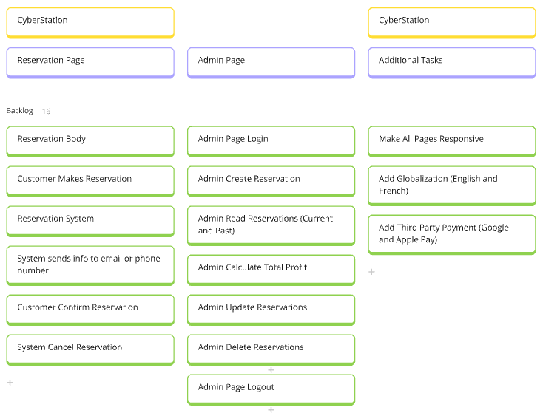

Nothing has changed on the user stories.

# Appendix 2

<https://miro.com/welcomeonboard/SlIybUFUcWtiek9Cb3dhZXVDUzlQcHVwYm12MlhUbzl1QndPRDFTRUx5amJQdUV2d3VlTEN2UU9vcWx3ZktkYXwzNDU4NzY0NjAyNzYwOTI2MjgwfDI=?share_link_id=819384719455>

We haven’t changed anything on the user stories map.

# References

Hefner, T. (2022, May 3). *What is a gaming lounge?*. Join It. <https://joinit.com/blog/what-is-a-gaming-lounge#:~:text=It%20can%20also%20include%20tournaments,of%20a%20hang-out%20hub>.

Nielsen, J. (2024, Jan 30). *10 Usability Heuristics for User Interface Design?* NN Group <https://www.nngroup.com/articles/ten-usability-heuristics/>

# Project Plan

Submitted inside of zip